Project Design Phase-II
Data Flow Diagram & User Stories

Date | 28 September 2026
Team ID | SWTID-2026-8954
Project Name | AI StudyBuddy
Maximum Marks | 4 Marks

Data Flow Diagrams:
A Data Flow Diagram (DFD) is a traditional visual representation of the information flows within a system. A neat and clear DFD can depict the right amount of the system requirement graphically. It shows how data enters and leaves the system, what changes the information, and where data is stored.

Diagram:
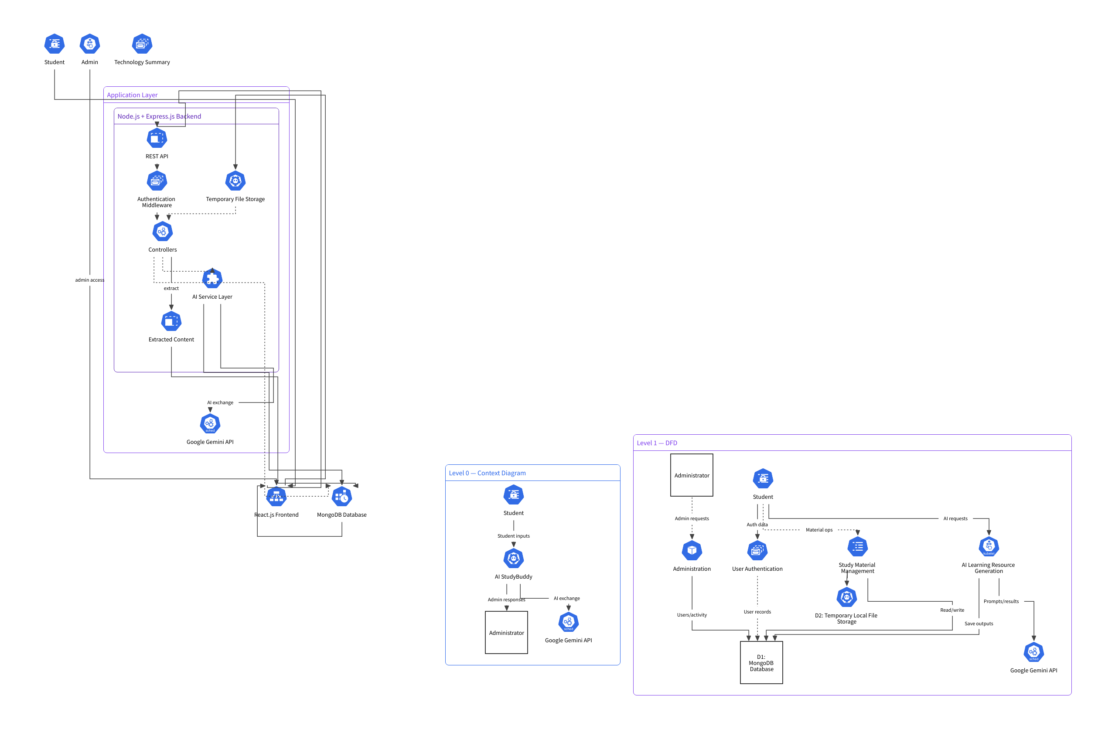

User Stories
User Type | Functional Requirement (Epic) | User Story Number | User Story / Task | Acceptance Criteria | Priority | Release
Student | Registration & Authentication | USN-1 | As a student, I can register for AI StudyBuddy using my name, email and password. | A new account is created successfully and the password is securely stored. | High | Sprint-1
Student | Registration & Authentication | USN-2 | As a student, I can log in using my registered email and password. | Valid credentials allow login and return an authentication token. | High | Sprint-1
Student | Registration & Authentication | USN-3 | As a student, my password is securely protected using hashing. | Passwords are stored as hashed values and are not stored as plain text. | High | Sprint-1
Student | Registration & Authentication | USN-4 | As a student, I can access protected features using JWT authentication. | Protected APIs reject requests without a valid authentication token. | High | Sprint-1
Administrator | User Management | USN-5 | As an administrator, I can access administrator-protected functions. | Only authenticated users with the admin role can access admin APIs. | Medium | Sprint-1
Student | Study Material Management | USN-6 | As a student, I can upload my study material to the application. | A valid file is uploaded, processed and stored with the student's account. | High | Sprint-2
Student | Study Material Management | USN-7 | As a student, I can view my uploaded study materials. | The application displays the student's stored materials without exposing restricted content unnecessarily. | High | Sprint-2
Student | Study Material Management | USN-8 | As a student, I can view an individual study material. | The selected material is retrieved successfully for the authenticated owner. | High | Sprint-2
Student | Study Material Management | USN-9 | As a student, I can delete my study material. | The selected material is removed from the database successfully. | Medium | Sprint-2
Student | Study Material Management | USN-10 | As a student, I cannot access another student's study material. | Unauthorized access is rejected with an access-denied response. | High | Sprint-2
Student | AI Learning Resources | USN-11 | As a student, I can generate a concise summary from my study material. | The system sends the material to the AI service and returns a generated summary. | High | Sprint-3
Student | AI Learning Resources | USN-12 | As a student, I can generate flashcards from my study material. | The system generates question-and-answer flashcards and stores them with the material. | High | Sprint-3
Student | AI Learning Resources | USN-13 | As a student, I can generate an MCQ quiz from my study material. | The system generates MCQ questions with options and correct answers. | High | Sprint-3
Student | AI Learning Resources | USN-14 | As a student, I can specify the number of flashcards or quiz questions to generate. | The requested count is passed to the AI service and the generated output follows the requested count where supported. | Medium | Sprint-3
Student | Personalized Study Planning | USN-15 | As a student, I can generate a personalized study plan based on my study material. | A day-by-day study plan is generated and returned successfully. | High | Sprint-4
Student | Personalized Study Planning | USN-16 | As a student, I can provide my goal, available study hours and number of days for the study plan. | The generated plan considers the provided goal, daily study time and duration. | High | Sprint-4
Administrator | Administration & Monitoring | USN-17 | As an administrator, I can manage users and monitor system activity. | Authorized administrator requests return the relevant user/system information. | Medium | Sprint-4
Student/Admin | Security & Error Handling | USN-18 | As a system user, I receive appropriate responses for invalid or unauthorized requests. | The API returns suitable HTTP status codes and error messages for invalid requests. | High | Sprint-4

User Story Summary
Total User Stories: 18
Sprint-1: 5 stories
Sprint-2: 5 stories
Sprint-3: 4 stories
Sprint-4: 4 stories
Primary Users: Student and Administrator
AI Service: Google Gemini API
Database: MongoDB / MongoDB Atlas
Authentication: JWT + bcryptjs
Backend: Node.js + Express.js REST API

